

**Superior University Gold Campus**

**Assignment #**

**Program:**

BS DATA SCIENCE

**Course Name:**

CN-LAB

**Submitted to:**

**SIR rasikh**

**Submitted by:**

Naveed Hussain  
(SU92-BSDSM-F22-018)

**IBEX NETWORK SYSTEN**

## Introduction

This project report provides a detailed overview of the network infrastructure designed using Cisco Packet Tracer for a building with three floors: Server Room (Floor 1), Employees (Floor 2), and Admin Office (Floor 3). Each floor has been configured with appropriate routers, switches, and PCs, and their interconnections and IP addressing schemes are described in detail.

## Floor 1: Server Room

The server room, located on Floor 1, includes the following components:  
- A central router (Router4) configured with IP address 10.0.0.1.  
- A switch (Switch0) connecting multiple PCs (PC3, PC4, PC5) and a server (Server0).  
- The server (Server0) is assigned the IP address 192.168.1.1 for internal services.  
- PCs on this floor have IP addresses in the range of 192.168.1.x.

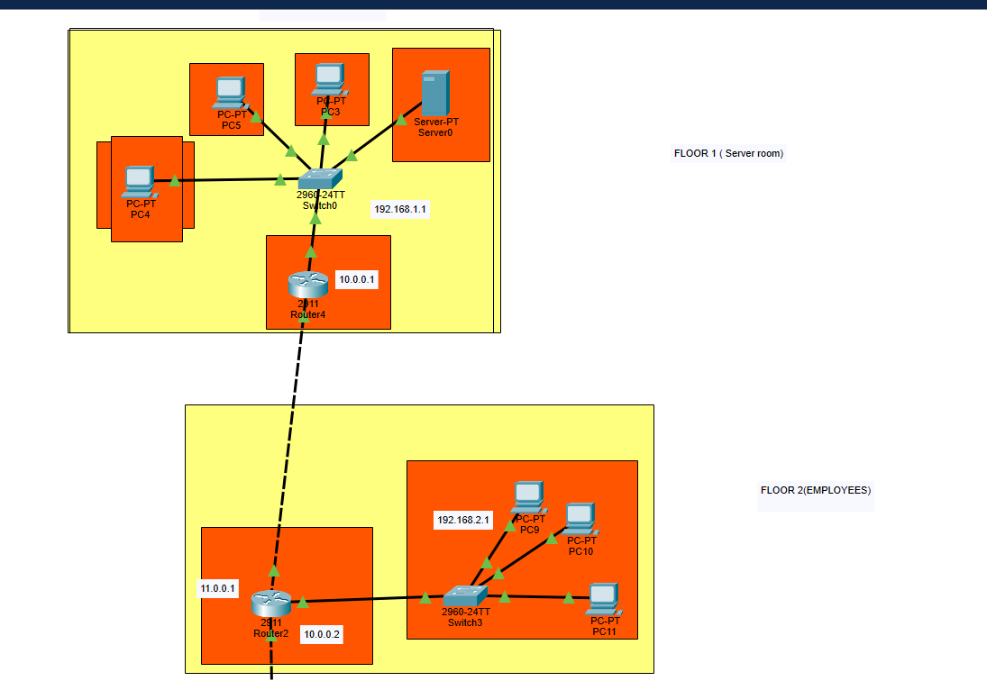

## Floor 2: Employees

The employees' floor, located on Floor 2, consists of the following components:  
- Router2 configured with IP addresses 10.0.0.2 (for communication with Router4) and 11.0.0.1 (for communication with Floor 3).  
- A switch (Switch3) connecting multiple PCs (PC9, PC10, PC11).  
- PCs on this floor have IP addresses in the range of 192.168.2.x.



## Floor 3: Admin Office

The admin office, located on Floor 3, includes the following components:  
- Router3 configured with IP address 192.168.3.1.  
- A switch (Switch2) connecting multiple PCs (PC0, PC1, PC2).  
- PCs on this floor have IP addresses in the range of 192.168.3.x.

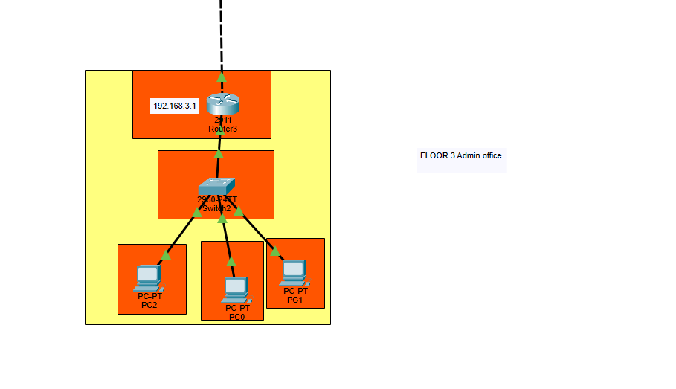

## Conclusion

This network design ensures efficient communication and data management across three floors. The use of separate routers and switches for each floor, along with proper IP addressing, enhances security and scalability. This setup is suitable for organizations requiring a structured and well-managed network.